## Step 1: Components Required

1. LDR (light dependent resistor)

2. Arduino UNO

3. LED

4. wires (jumper)

5. resistors (1k,100k)

6. Battery (for UNO)

7. Breadboard

## Step 2: Connection

1. Connect the +5V VCC pin of the arduino to the one end of LDR fixed on the breadboard .
2. Connect other end of the LDR to the resistor (100k) and from this end of ldr itself connect the wire to the analog pin (A0) from the arduino and the other end of the resistor is connected to ground and thus forming a potential divider circuit .
3. Connect the pwm pin 1 or PB1 or OC1A pin of the arduino to the anode(+) of the LED and the cathode(-)of the LED is connected to ground via 1k resistor.(use different value to get stable brightness).
4. Connect the power supply to the arduino. (not needed if you supply power through the computer)

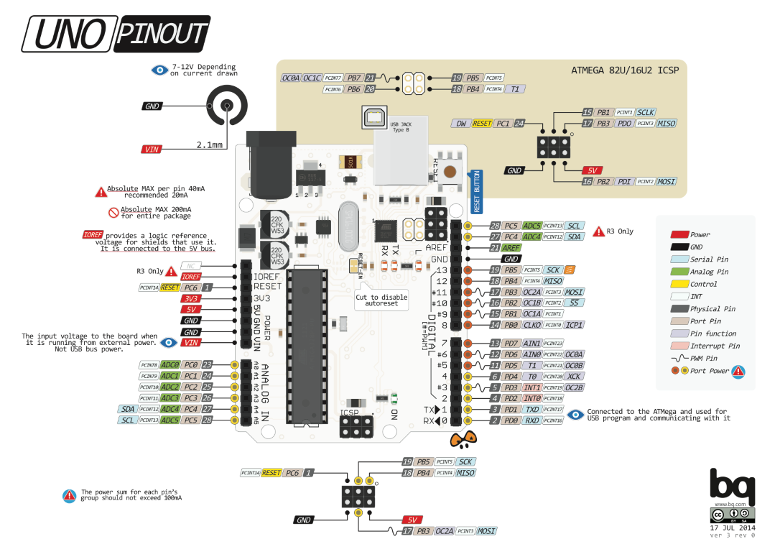

**STEP 4: CODE**

#include<avr/io.h>

#include<util/delay.h>

void adc_init()

{

ADMUX = (1<<REFS0); // AREFF, Internal Vref turned off

ADCSRA = (1<ADEN)|(1<<ADPS2)|(1<<ADPS1)|(1<<ADPS0); // enable adc, next three i.e. ADPS to set the prescaler to 128

ADCSRA |=(1<<ADSC); // to start the conversion

}

void pwm_init()

{

TCCR1A |= (1<< COM1A1)|(1<<WGM11); //clear OC1A on compare match( set output to low level) ,PWM phase correct

TCCR1B |= (1<< CS11); //selecting prescalar i.e., clk/8(From prescaler)

}

int main()

{

DDRC = 0x00; // set the pins to input mode

DDRB = 0xFF; // set the pins to output mode

adc_init(); // initalize adc

pwm_init(); // initialise pwm

ADMUX|=(ADMUX & 0xF8);

while(1)

{

ADCSRA |= (1<<ADSC); // start conversion

while(!(ADCSRA & (1<<ADIF))); // till the conversion's over

ADCSRA|=(1<<ADIF); // clear flag

OCR1A=ADC;

}

}

**NOW YOUR TASK:**

**CONTROL THE SPEED OF A DC MOTOR USING A POTENTIOMETER…**